Business Process

Business Background

Where does our program work at? Steam.

Steam is the largest digital distribution platform for PC gaming, with an estimated 75% of the market share in 2013 according to IHS Screen Digest. According to SteamDB, 12642 new games hit the shelf of Steam during 2022. Steam market now provides more than 50000 games and other products, various and abundant.

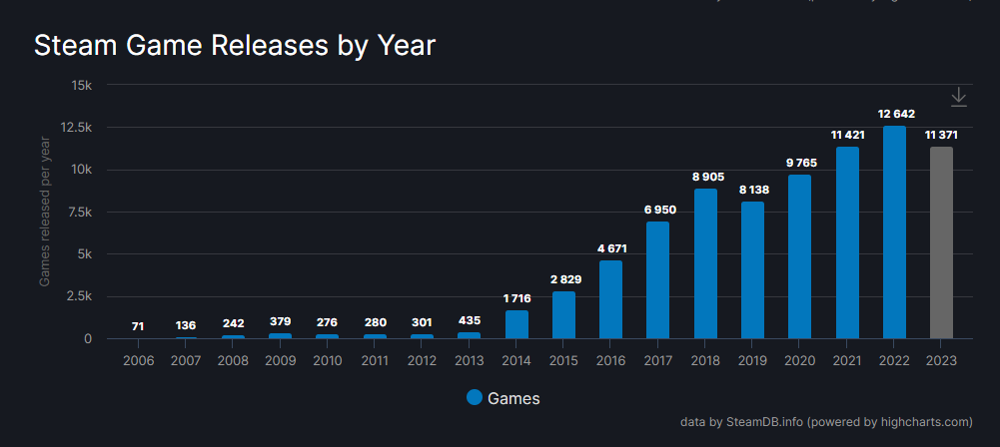

Searching for favourite games or service tend to be time-consuming and trying. Even if players find what they want, figuring out the most economical purchase plan is also a troublesome business. Such a market drown in needless information is what our program is aiming at. Customers are in great need of a service that help them save their time and money. There are about 30,000,000 online users of Steam now, that means, 30,000,000 different requirements.

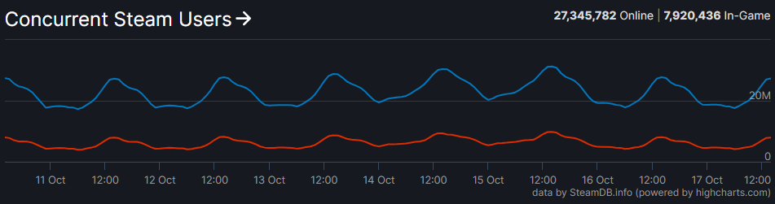

Business Process Model

To express our business process, based on some knowledge of Business Process Modeling Notation, we drawed a flow chart to present the business process of our service.

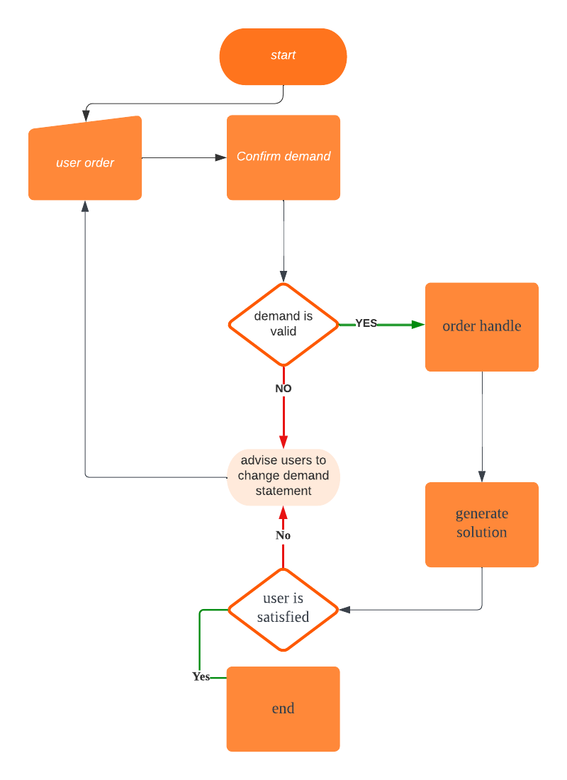

Business Goal

Satisfy users, complete their orders.

Process Input

Users’ demand.

Process output

Possible solution, practical plans to pursue products in economical ways.

Process overview

The whole process start with customers make their orders. The software receive the demand of users, usually the tags of games they want as input. The software will confirm the demand of users. If users input unidentified tags, they will be advised to change their input in a more practical way. If their input is valid, the software will then handle their order and generate possible solutions of their order. If users are not satisfied with the solutions, the software will advise them to change their inputs. If users are satisfied with their solutios, the process is end.

Process problems

It’s hard for our software to handle too complex requirements of users. Users may input a sentence to describe their demand, while it will probably invalid. Such situation may dissatisfy users and cause them to abandon our software.

To avoid this, it’s necessary to improve our search system. Applying GPT is a viable way.

Context model

The graph below shows the cotext model of our software.

Main system

The main system is connected to four subsystems:

user interface, market analysis subsystem,

trade subsystem and inventory maagement subsystem.

User interface

Main system send important innformation and warnings to user interface, so that users can be informed. Users input their customizedtrade commands in user interface, and user interface will upload them to main system.

Market analysis subsystem

Market analysis subsystem receives typical item analysis request from main system. Trade strategy based on real time information from market monitor will also be uploaded to market analysis system. In this way the system is able to handle request in consideration of newest informaion.

Trade subsystem

Main system send trade commands to trade subsystem, and trade outcomes also comes to trade subsystem. This subsystem handles trade operations.

Inventory management subsystem

Inventory management subsystem collect current inventory information and send it to main system to ensure the information of inventoory is consistent.